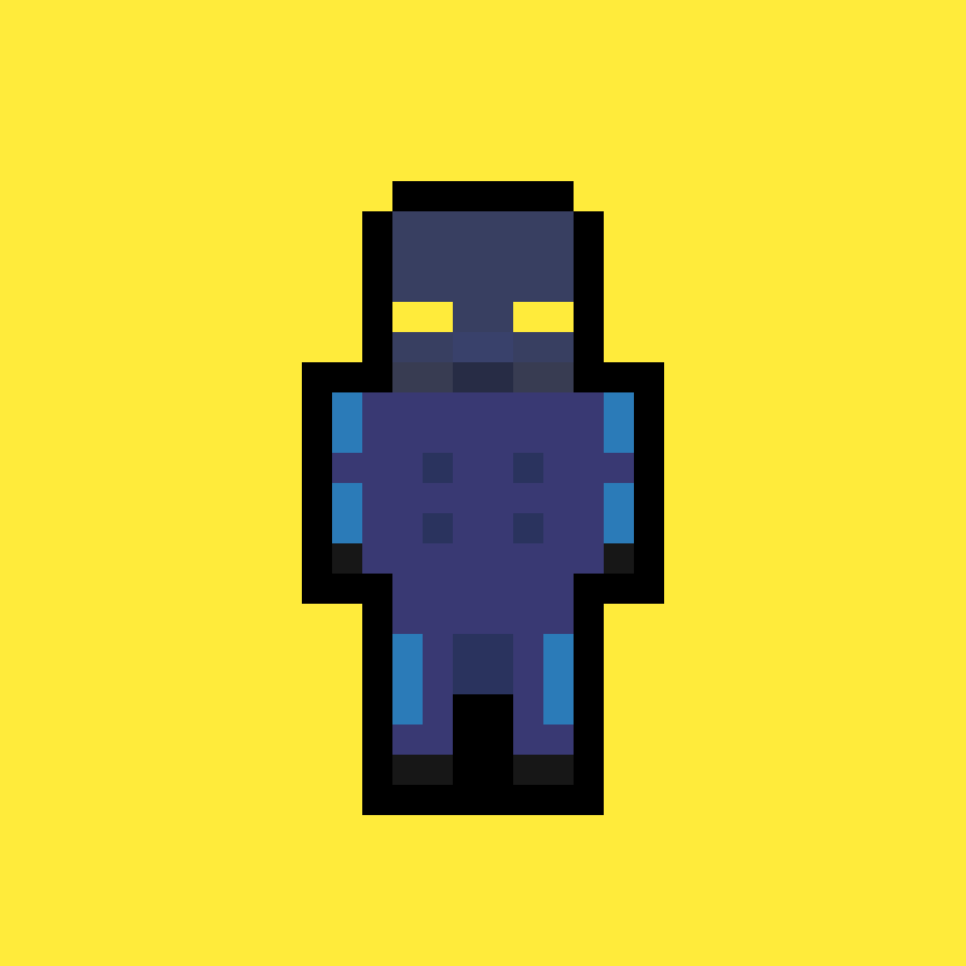

Looks distinctive and defiantly hostile though slightly sci-fi.

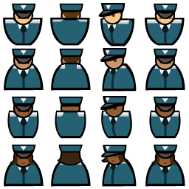

Basic design, use of blue makes it easy to see who they are

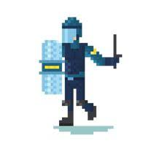

Blue colour pallet, easy connection

* Basic slime enemy

Hero Cop

Kinda creepy with pale face and lanky frame

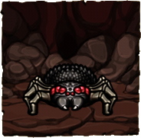

Everyone hates spiders



Medieval knight

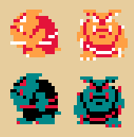

Simple yet obviously hostile



No visible face makes them look evil and dehumanises them



Would have to tone down bug motif

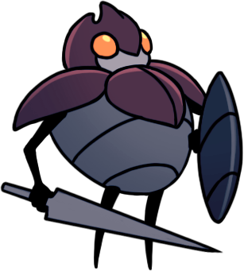

Sword and Shield convey ‘defender’ but size is threatening